Pattana unveiled as new MENA Golf Tour venue in Thailand

Big boost for the tour’s rising popularity in the Far East and beyond

DUBAI, Aug 2016 — Pattana Golf Club and Resort will make its debut as one of the host venues when the MENA Golf Tour returns to Thailand in 2017 in a clear manifestation of the tour’s rising popularity index in the Far East and beyond.

With Pattana coming on board, the MENA Golf Tour will have a minimum of three tournaments during its second visit to the kingdom in May as Banyan Golf Club and Mountain Creek have already committed to continue their support after successfully hosting the tour events earlier this year.

“We feel proud and privileged to join hands with Pattana. Their support augurs well for the growth of professional golf and further strengthens our resolve to create meaningful playing opportunities for our members to showcase their skills on a global basis,” said Mohamed Juma Buamaim, chairman of the MENA Golf Tour.

“With an impressive portfolio of world-class courses, Thailand has already established its credentials as one of the most popular golf destinations in the world and the addition of a new MENA Golf Tour event at Pattana will further realise the country’s huge tourism potential.

“The MENA Golf Tour events will provide a great opportunity for the Thai talent to gain valuable World Ranking Points in addition to promoting Golf Citizen, one of the fastest growing online tee time booking engines which has richly-diverse golf courses on its network.

The Pattana management was equally upbeat about welcoming the MENA Golf Tour party to their course.

“We are very excited with our association with the MENA Tour, which, I am confident, will further stimulate the growth of golf. It will be a great opportunity for us to showcase our championship course, which we are proud of,” said Rujirapun Juangroongruangkit, Vice Presedent of Pattana Golf Club.

“We look forward to welcoming MENA Golf Tour members and I am confident they will have a memorable experience playing on our course that offers value for money.

“We are motivated to make this one of the most popular event in Thailand and look forward to welcoming fans, players, sponsors and organisers alike to Pattana in May 2017,”

"Hosting international sporting events are in sync with Thailand’s drive to increase in-bound visitor numbers and contributes significantly to the economic growth of our city,” he added.

Located a mere 90 minutes from Bangkok, Pattana Golf Club and Resort boasts a full range of premium accommodations and amenities, meeting and event facilities, championship 27-hole golf course, and 7,000 capacity stadium.

Set up in 2004 by Dr. Somporn Juangroongruangkit in memory of her husband who established the Thai Summit Group, the Pattana layout, highlighted by a mixture of well-placed trees, bunkers and exciting greens, tests every aspect of the game.

Himself a passionate lover of the greens Dr. Pattana Juangroongruangki may have left for the links in the sky, his legacy will continue to live on forever, inspiring a culture of healthy lifestyles at Pattana Golf Club and Resort.

An initiative of the Shaikh Maktoum Golf Foundation, the MENA Golf Tour was created in 2011 with the aim of developing golf in the region. It is affiliated to R&A, the worldwide golf governing body based in the home of golf, St Andrews, and the Arab Golf Federation and enjoys the Official World Golf Ranking (OWGR) status.

Multiple European Tour starts, including the Omega Dubai Desert Classic, the Hassan II Trophy and the Maybank Championship Malaysia in addition to full playing privileges on the Sunshine Tour and exemptions into the Final Stage of the Asian Tour Q-School for the leading three professionals are some of the added incentives for the MENA Golf Tour members.

Ends...
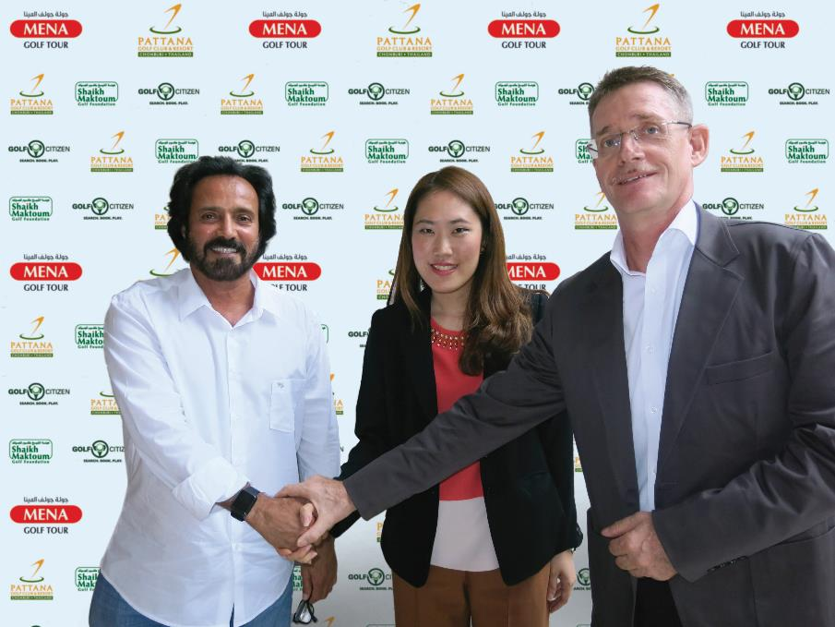
Pic caption:

Mohamed Juma Buamaim, chairman of the MENA Golf Tour with Rujirapun Juangroongruangkit, Executive Vice President of Pattana Golf Club, and Thomas Tapken, Managing Director of Pattana Golf Resort & Sports Destination

