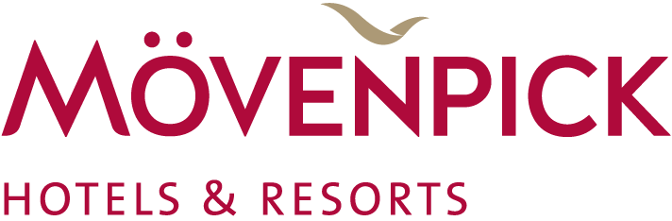
News Release
Mövenpick Hotels & Resorts to treat guests to a special edition ‘Chocolate Hour’ in celebration of World Chocolate Day

Swiss hospitality firm to showcase the versatility of chocolate in fun and immersive ways at hotels globally to mark a very sweet occasion

Baar, Switzerland, 21 June 2018 – Mövenpick Hotels & Resorts is celebrating World Chocolate Day in style, indulging guests of all ages in immersive ‘Chocolate Hour’ experiences that are fun and wonderfully delicious.

Chocolate Hour is one of Mövenpick’s brand signatures, staged daily in its hotel lobbies around the world, with in-house chefs hosting live demonstrations and entertaining experiences, from rolling truffles to icing cupcakes. It offers guests the chance to taste complimentary chocolate presented in novel ways, which reflects the hospitality firm’s we make moments brand vision.

To mark the sweet occasion, which takes place on July 7 and quite simply applauds and encourages the consumption of chocolate, Mövenpick properties across the globe will be orchestrating a special edition of Chocolate Hour, inviting guests to discover new and exciting chocolate creations that bring this wonder food and its virtues to life.

Chocolate Hour also showcases Mövenpick’s world-famous chocolate and brings the Swiss heritage of the company – and chocolate – to life, ultimately delivering moments of delicious joy for guests every single day.

Some of the most innovative and meaningful Chocolate Hour experiences being offered on World Chocolate Day at Mövenpick Hotel & Resorts properties include:

In Europe
Chocolate was first introduced to Europe in the 1550s and Mövenpick’s properties across the region are honouring this in many different ways:
- Mövenpick Hotel Hamburg is recreating the city’s skyline using chocolate showcasing pralines, deserts and bites in an eye-catching display.
- Mövenpick Hotel Stuttgart Airport is offering an exquisite tasting experience giving guests the chance to try orange-chocolate chips and white chocolate with berries.
- Mövenpick Hotel Istanbul’s lobby is overflowing with a chocolate fountain and truffle chocolates hand-decorated by talented chefs.

In Africa
- It’s fun and games at Mövenpick Resort Soma Bay in Egypt where the hunt is on to find the ‘magic nut’ in the house-made chocolate.
- Mövenpick Resort & Marine Spa Sousse offers a magnificent buffet of homemade chocolate, local delights and seasonal fruits and invites children from its Little Birds kids’ club to join in the fun on World Chocolate Day.

In Asia
- Mövenpick Hotel Mactan Island Cebu is using locally-grown cocoa to create special Filipino-inspired treats that not only introduce guests to local delicacies, but support the island’s agricultural workers.
- Mövenpick Suriwongse Hotel in Chiang Mai is concocting a Swiss chocolate dip to accompany a traditional northern Thai snack – crispy rice cakes (Khao Tan) with traditional watermelon sauce.
- Mövenpick Hotel Colombo chefs are mastering the art of using traditional Sri Lankan ingredients such as ginger, cinnamon, cardamom and chilli to make the “best chocolates in town”.

In the Middle East
- Mövenpick Resort & Spa Tala Bay Aqaba’s Chocolate Hour is focusing on family fun, with chefs, parents and kids creating chocolate displays together.
- At Mövenpick Hotel Ibn Battuta Gate Dubai, Chocolate Hour is an extravagant jewelry-inspired affair with exquisite gold-dusted chocolate medallions, handcrafted chocolate jewelry and edible diamonds handmade by the pastry team and displayed in the property’s grand hall.
- Mövenpick Hotel City Star Jeddah makes chocolate crepes the hero in a special live cooking session that tantalises the tastebuds.

-Ends-
For further information, please contact:

Laura Perez Diaz | VP Communications Corporate
Shatha Tower Floor 39, Office 3903 | Dubai, United Arab Emirates
laura.perez@movenpick.com

Tina Seiler | PR & Communication Manager Corporate
Oberneuhofstrasse 12 | 6340 | Baar | Switzerland
Phone +41 41 759 19 28 | tina.seiler@movenpick.com

About Mövenpick Hotels & Resorts:
Mövenpick Hotels & Resorts is a modern, international upscale hotel management firm with a we make moments business philosophy, recognising that small gestures make a big difference to its guests, business partners and its workforce of more than 16,000 team members. The company manages more than 83 hotels, resorts and Nile cruisers across Africa, Asia, Europe and the Middle East and is on track to meet its target of operating 125 properties by 2020. Headquartered in Baar, Switzerland, Mövenpick Hotels & Resorts’ values reflect its Swiss roots and rich culinary heritage and it is passionate about delivering gastronomic excellence and intuitive service – all with a personal touch. Committed to sustainable practices and caring for local communities in the destinations where it operates, Mövenpick is the most Green Globe certified hotel company in the world. For more information, please visit www.movenpick.com.

